SCNI/01294/2021

ANNE APIYO OPIYO

ASSIGNMENT 4: SOFTWARE DEVELOPMENT.

SYSTEM MODELLING

***1.Pick an appropriate software engineering methodology (2 marks)***

For developing a world clock app, an Agile methodology such as Scrum or Kanban would be a suitable choice. Agile methodologies prioritize customer satisfaction, continuous delivery, and collaboration between the development team and stakeholders. These methodologies can help the development team to respond quickly to changing requirements and deliver a high-quality product within a short time frame.

***2.Your system uses cases, come up with the following system modelling schemes***

i) context model:

a diagram that provides an overview of a system and its interactions with external entities.

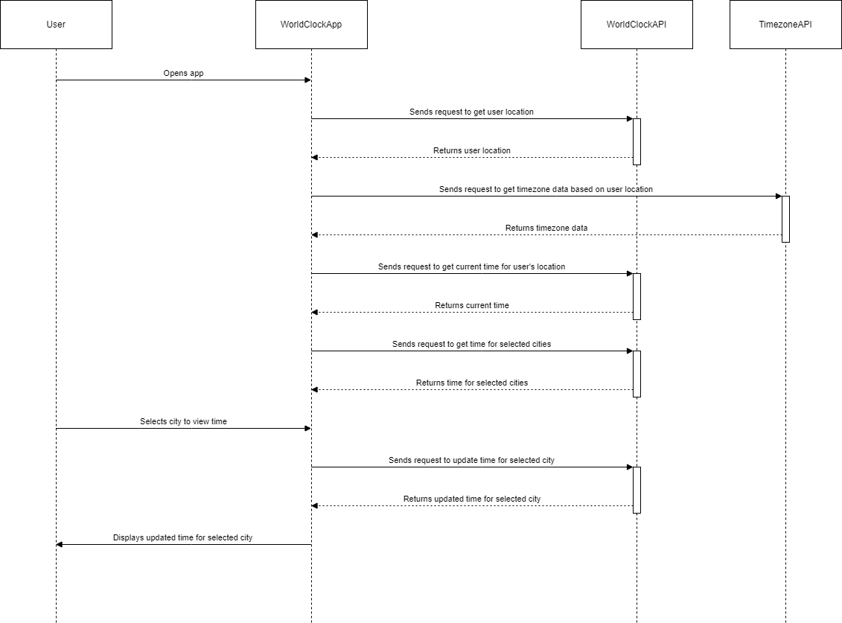

ii) Interaction Model:

The interaction model for a world clock app describes how the entities identified in the context model interact with each other to support the app's functionality.

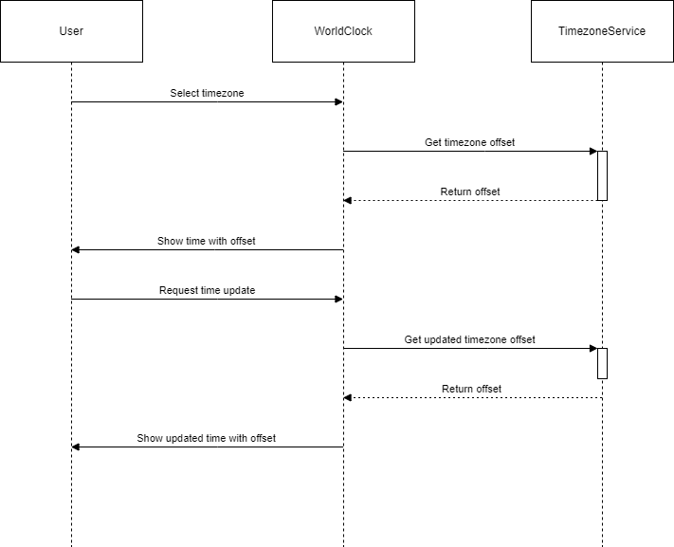

iii) Structural Model:

The structural model for a world clock app describes the underlying data structure and organization of the app's components.

The entities include: the user, world clock, time-zone API, Database.

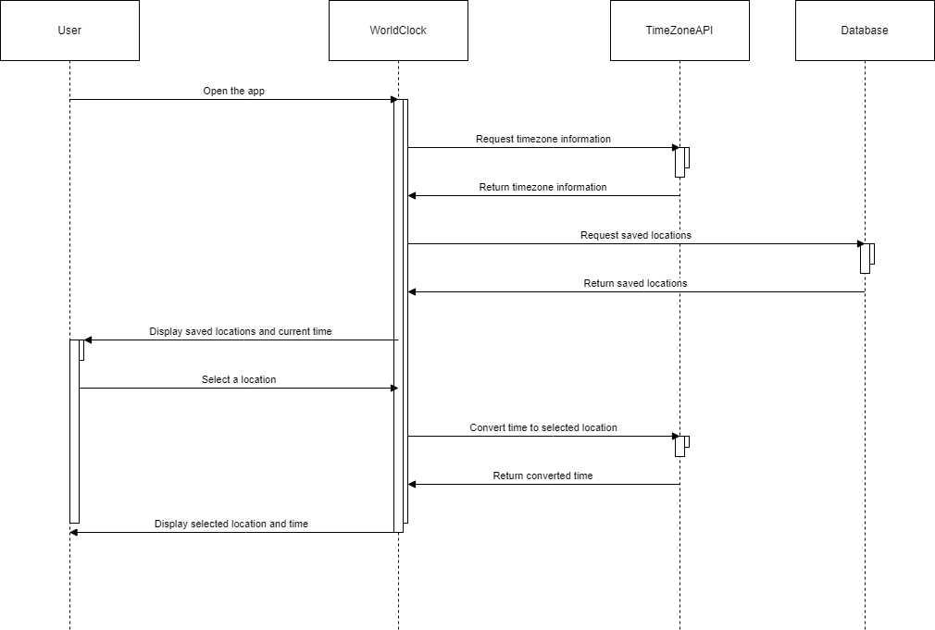

iv) Behavioral Model:

The behavior model for a world clock app describes how the app behaves in response to user interactions and events.

